**YOUR PROVIDERS**

Glen Silas, MD / Ivette Couret, MD / Sona Patel-Grimm, MD, MPH /

Courtney Ramsey-Johnson, MD / Rachel Bridge, MD / Maddie Mahoney WHNP

**OUR OFFICE LOCATIONS**

3025 Hamaker Court 13135 Lee Jackson Memorial Hwy.

Suite 200 Suite 200

Fairfax, VA 22031 Fairfax, VA 22033

Office: (703) 698-8060 Office: (703) 698-8060

Fax: (703) 876-4691 Fax: (703) 620-1364

**PLEASE VISIT OUR WEBSITE**

[www.cwcare43.com](http://www.cwcare43.com)

**AFTER HOURS / WEEKEND DIRECT PAGING NUMBER**

**571-210-6024**

**(If you call our office number after hours/weekends, it will also prompt you to page us.)**

**FOR URGENT PREGNANCY CONCERNS**

**CALL OR PAGE US!** There is a physician on call and available **24/7** to address your urgent concerns. We would **ALWAYS** rather you call or page us and have everything be ok than for you to wait or worry with an urgent problem.

These are the urgent pregnancy concerns **WE WANT** you to call us about:

* If you think you are in labor
  + If you are < 37 weeks, more than 5 contractions within an hour
  + If you are > 37 weeks AND it is your first baby, contractions every 5 minutes apart or less for 2 hours consistently
  + If you are > 37 weeks AND it is NOT your first baby, contractions every 7-8 minutes apart or less for about an hour
* If you have decreased fetal movement
  + Try kick counts if you are > 28 weeks by drinking something cold and/or sugary (if you are not diabetic), lay on your left side and place your hands on your belly, and count how many times the baby moves; the baby should move at least 10 times within 2 hours
  + Or call/page us right away
* Vaginal bleeding
* Leaking of fluid
* Any other urgent concerns that you are not sure what to do about

**PRENATAL VISIT SCHEDULE**

Below you will find a guide on how often you will have prenatal visits and a basic outline of what you can expect during your visits and pregnancy. Keep in mind this schedule may be modified to meet your unique needs throughout the pregnancy.

**AT EACH PRENATAL VISIT**

1. We monitor your urine, weight and blood pressure
2. We listen to the baby’s heartbeat with an external fetal Doppler (after 12 weeks of pregnancy)
3. We want you to let us know about any concerning symptoms including cramping/contractions, bleeding, leaking of fluid, and decreased fetal movement

**FIRST TRIMESTER (0 – 13 Weeks)**

* You will have 1-2 visits
* At your 1st visit, you’ll have an ultrasound to confirm the pregnancy, a physical exam, and infection testing for gonorrhea/chlamydia with pap smear if needed
* We will discuss genetic screening test options
  + 1st trimester: nuchal translucency and/or cell free DNA testing and/or carrier screening
  + 2nd trimester: quad screen
* Around 12 – 13 weeks, you will have routine prenatal bloodwork to test for anemia, blood type, HIV, Hepatitis, Syphilis, Rubella immunity, and thyroid function. Genetic screening can also be done at that time.
* You will receive information about diet, exercise, and safe medications during pregnancy

**SECOND TRIMESTER (13 – 28 Weeks)**

* You will have appointments every 4 weeks
* You will receive a referral to go to a radiology center for a detailed ultrasound to evaluate the baby’s anatomy. If you desire, you may find out the gender of the baby during this ultrasound
* Between 26 – 28 weeks, you will have lab work to screen for gestational diabetes and anemia

**THIRD TRIMESTER (28 – 40+ Weeks)**

* You will have appointments every 2-3 weeks until 35 weeks, then you will be seen weekly
* You will be asked to start considering (if you haven’t already) pediatricians, cord blood banking options, an Inova Fairfax Hospital tour, pre-registering for the hospital online, childbirth/newborn care classes, epidural vs. unmedicated childbirth
* You will be recommended to have the Tdap vaccine
* AVOID TRAVEL AFTER 32 – 34 WEEKS
* You will be screened for a common bacteria called Group B Strep (GBS)
* You may be offered cervical exams at 35+ weeks
* If your pregnancy continues beyond your estimated due date (ie, 40 weeks), we will discuss inducing labor

***Remember: it is OK to work until the baby arrives unless you have been told otherwise***

**WEIGHT GAIN RECOMMENDATIONS**

**National Academy of Medicine* Recommendations for Weight Gain in Pregnancy**

|  |  |  |
| --- | --- | --- |
| **Pre-pregnancy Body Mass Index Category (kg/m2)** | | **Recommended Maximum Weight Gain** |
| Underweight (less than 18.5) | 28 – 40 pounds | |
| Normal weight (18.5–24.9) | 25 – 35 pounds | |
| Overweight (25.0–29.9) | 15 – 25 pounds | |
| Obese (30 or greater) | 11 – 20 pounds | |

* Previously known as the Institute of Medicine.

Source: Fox N. Dos and Don’ts in Pregnancy. Obstetrics & Gynecology 2018; 131: 713-721.

**EVERYDAY NUTRITION RECOMMENDATIONS**

You only need to consume about 300 additional calories per day.

The US Department of Agriculture created this website to help personalize nutrition during each trimester of pregnancy:

[**www.myplate.gov/life-stages/pregnancy-and-breastfeeding**](http://www.myplate.gov/life-stages/pregnancy-and-breastfeeding)

In general, we recommend 5 small meals per day to include the following:

* **WATER**: At least 12 cups per day (about 1-2 cups every hour while you are awake)
* **FIBER RICH FOODS**: High fiber cereals, cooked beans ([www.health.gov](http://www.health.gov) search “high fiber” for more)
* **PROTEIN**: 3-4 servings per day (eg, fish, eggs, chicken, beans, nuts, greek yogurt)
* **FRUITS**: 3-4 servings per day (eg, apples, bananas, pears, peaches, prunes, mango, tomato)
* **VEGETABLES**: 3-4 servings per day (eg, spinach, peppers, cucumbers, broccoli)
* **WHOLE GRAINS**: 2-4 servings per day (eg, whole grain bread, cereal, oatmeal, brown rice)
* **CALCIUM RICH FOODS**: 2-4 servings per day (eg, skim or 1% milk, yogurt, cheese)
* **PRENATAL VITAMIN:**
  + Folic acid 400-800mcg
  + DHA 200-300mg
  + Vitamin D 600 international units
  + Calcium 1000mg
* Be sure milk/cheese/dairy products are **PASTEURIZED**
* Be sure pork/poultry/fish/eggs/meat are **FULLY COOKED**

**EXERCISE SUGGESTIONS**

**Exercise *EVERYDAY* for at least 30-60 minutes unless you have been told not to.**

**There are currently no heart rate restrictions in pregnancy. Listen to your body.**

**AVOID high impact activities after 20 weeks.**

* Continue any exercise you were doing prior to pregnancy (eg, experienced runner/jogger)
* Brisk walking, swimming and water workouts, stationary biking, elliptical
* Modified yoga / modified Pilates: avoid poses requiring you to lie on your back for long periods
* Light weights: 5-10 pound hand held weights; decrease the amount of weight but increase reps to achieve the same effect

**MINIMIZE THE FOLLOWING:**

* Caffeine: no more than 2 cups per day (max 200mg per day)
* Sugary Foods: soda, juice, cookies, cakes, ice cream
* White Foods: white bread, white rice, potatoes, pasta
* Junk Foods: chips, fries, fried foods
* Deli meats (unless prepackaged or well heated prior to eating): 12 oz per week

**ELIMINATE THE FOLLOWING:**

* Alcohol / Nicotine / Tobacco / Illicit Drugs
* Foods that may carry Listeria (a bacteria that can cause pregnancy loss)
  + Anything unpasteurized (eg, milk/soft cheeses)
  + Smoked foods (eg, fish)
  + Raw/undercooked meats

**SEAFOOD**

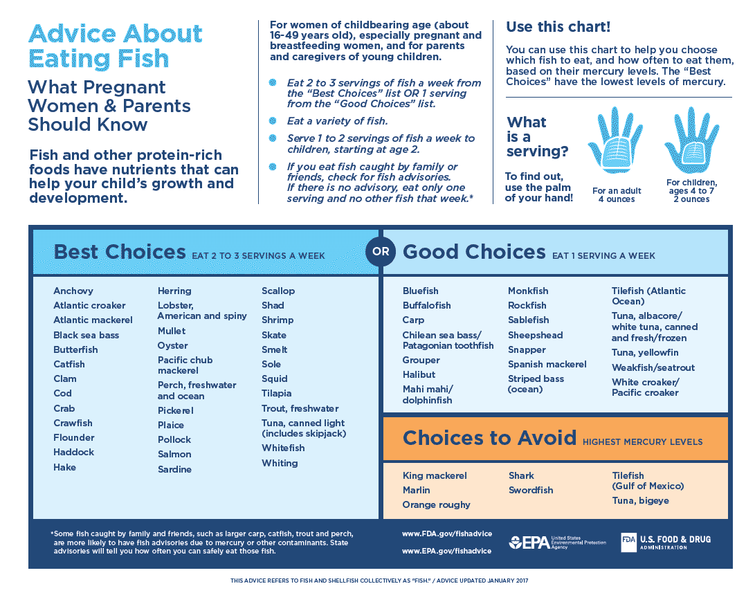

**THIRD TRIMESTER “HOMEWORK”**

1. Consider signing up for a childbirth and/or newborn care class
2. Consider signing up for a breastfeeding prep class
3. Select your pediatrician
4. Consider signing up for a hospital tour
5. Select your car seat and consider having the installation inspected
6. Consider cord blood banking (public or private)

**FREE Live Online Prenatal Classes** <https://info.tummytalks.com/cwc>

**Childbirth Prep, Childbirth Express, Cesarean Birth Prep, Baby Care for Dads, Twins/Triplets & More, Baby Care, Breastfeeding, From Bump to Baby, Sibling Preparation, Grandparenting, New Moms Group, New Moms Return to Work Group**

[www.inova.org/wellness/childbirth-education](http://www.inova.org/wellness/childbirth-education)

**Prenatal Yoga, Mommy Bootcamp, Mommy & Me Yoga, Infant CPR, Family and Friends CPR**

[www.inova.org/class-reg](http://www.inova.org/class-reg)

**Maternity Hospital Tours**

[www.inova.org/childbirth](http://www.inova.org/childbirth)

**Northern Virginia Lactation Consultants (703-425-BABY) (703-425-2229)**

(Prenatal Classes, Breastfeeding Consultations, Hospital Grade Pump Rental and Pump Retailer)

[www.novalactation.com](http://www.novalactation.com)

**INOVA FAIRFAX HOSPITAL PRE-REGISTRATION**

[www.inova.org/register-my-delivery](http://www.inova.org/register-my-delivery)

**OTHER INTERNET RESOURCES**

The American Congress of Obstetricians & Gynecologists: [www.acog.org/patients](http://www.acog.org/patients)

March of Dimes: [www.marchofdimes.org](http://www.marchofdimes.org)

Centers for Disease Control and Prevention: [www.cdc.gov/pregnancy](http://www.cdc.gov/pregnancy)

American Academy of Pediatrics: [www.healthychildren.org](http://www.healthychildren.org)

DC Breastfeeding Coalition: [www.dcbfc.org](http://www.dcbfc.org)

**OVER THE COUNTER MEDICATIONS SAFE TO USE DURING PREGNANCY**

(Just follow the instructions on the bottle)

**FEVER / HEADACHE / BODY ACHES**

* Acetaminophen (Tylenol): regular or extra strength
* **AVOID**: aspirin containing products and ibuprofen unless under the instruction of your provider

**NAUSEA / VOMITING**

* Vitamin B6 50mg: 1-3 times per day

PLUS

* Doxylamine succinate (Unisom Sleeptabs) 1-3 time per day as follows:
  + ½ tablet in the morning and/or mid-afternoon, and 1 tablet at bedtime
* Ginger tea, ginger ale, ginger chews, etc
* Sea bands, acupuncture
* Peppermint oil aromatherapy
* Flat coke

**CONSTIPATION / HEMORRHOIDS**

* WATER: about 1-2 cups of water every hour during the day while awake
* Fiber supplements: Citrucel, Fibercon, Metamucil, bran cereal
* Stool softeners: Colace (docusate), Pericolace, Senokot
* Milk of Magnesia
* Glycerin rectal suppositories
* Miralax
* Prunes
* Preparation H (phenylephrine HCL 1%)
* Tucks pads (witch hazel wipes/compresses)
* Anusol (Hydrocortisone topical or suppositories)

**COLD / FLU / CONGESTION / ALLERGY**

* Any Tylenol (acetaminophen) products (regular, extra strength, cold/sinus)
* Sudafed original or new
* Any Robitussin product
* Triaminic
* Benadryl
* Theraflu
* Chloraseptic/throat lozenges, cough drops
* Mucinex
* Claritin, Zyrtec, Allegra
* Saline nose drops/sprays
* Flonase
* Vicks Vapor Rub

**HEARTBURN / REFLUX / INDIGESTION / UPSET STOMACH / GAS**

* Tums, Rolaids (but too much can cause constipation)
* Mylanta, Maalox (but too much can cause diarrhea)
* Pepcid (famotidine), Prilosec, Prevacid, Nexium
* Gas X (simethicone), Mylicon, Phazyme

**DIARRHEA**

* Imodium
* Kaopectate
* Pepto Bismol
* BRAT Diet: bananas, white rice, applesauce, black tea, avoid dairy for at least 24 hours
* Gatorade, Pedialyte

**YEAST INFECTIONS**

* Monistat 7 day treatment (miconazole)
* Gyne-Lotrimin (clotrimazole)

**ANEMIA**

* Slow-Fe
* Vitron C